**Gym:** Emerald City, Monroe, WA ()

**Trainer:**  Caitlin

**Fitness Plan**

**Prev (2014):** 183.0 lbs (10%) 164.7 lbs / 18.3 lbs

**Start (10/16):** 186.6 lbs (16.4%) 156.0 lbs / 30.6 lbs

**Today (12/7):** 180.6 lbs (15.3%) 153.0 lbs / 27.6 lbs

**Goal:** 180.0 lbs (8.0%) 165.6 lbs / 14.4 lbs

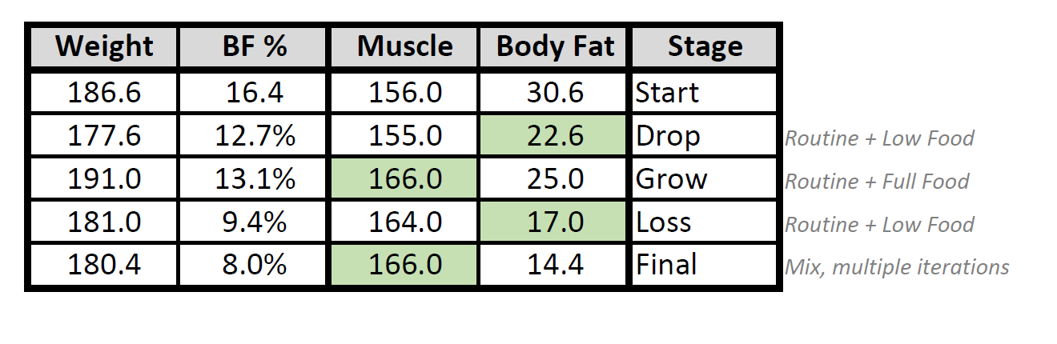 **+10 lbs / -16 lbs**

**Time Target:** 1 year

Start: 11/10/16

Complete: 11/10/17

**Activity Keypoints**

* plan – build up a routine that is pointed towards longer term and establishment of habit
  + You can do extra if desired, no problem (e.g. 6 days per week)
  + Typical high-endurance routine is 4-5 days/wk
* target - 300 minutes over 4 days/wk
* The average healthy weight loss pace is 1 lbs/month

**Note:**

Consider supplementing your diet with a Probiotic and an Amino Acid

* + Your plan calls for at least one year
* Gain muscle first, don’t emphasize weight loss until after
  + “*Convert your weight, it’s not a Lose/Grow game you see*”
  + This minimizes number of cycles and time taken dramatically
  + There will be several rounds to final achieved goals
* Diet and diet-balance are one of the most important long term components of your plan.
  + A primary goal is healthy lifestyle balance, ensure you target something that you can maintain

**Supplemental Nutrients Plan**

Protein (after workout) – 1 Scoops w/Almond Milk

Aminos (after workout) – 1 Scoop

Vega One (lunch replace) – 2 Scoops w/Almond Milk

Water (daily) – 70 oz.

**Routine Plan**

Justin will follow the plan delivered by Caitlin on 12/7/16 until further notice, targeting 4 lift days and 1 cardio days per t days, with one day remaining for rest:

**L** / **L** / **C** / **L** / **L** / **R**

**Training Plan 1.0**



**Central Lift Style Points**

* Always squeeze the shit on grips **during** a lift. Grip strength & muscle activation bloom here!
* Always squeeze on **entry** into a lift and on **exit**. Muscle engagement and activation grow here
* Rotate on entry and on exit from standing curls

**Key**

* *Drop-Set*: When you are done with your last set, immediately grab weights that are 5lbs. lighter (if using dumbbells) or drop the weight one plate (if using a machine or cables) and do as many reps as you can, when you no longer can perform the exercise without maintaining form, drop the weight an additional 5lbs./1 plate, and repeat the reps to failure
* *Failure*: performing an exercise to complete exhaustion, while maintaining perfect form. When your form breaks, you have failed.

**Present Nutrition Plan**





**Configuration**

Justin 🡪 Micros

Caitlin 🡪 Macros

**Nutrition Plan Idea (Upcoming)**



